  - 20260913

Mobilab user guide
  - Observe, contribute and work together.
Territorial inquiry · ZFT Sud · ZFT Nord TNT Chiers-Alzette · LTC-PSP educational strand

In this edition | For whom?
My activity and pathways Workbooks, contributions and sources Documentary assistant and local synthesis | Participants Working groups Partners, coordination and administration

Edition 2.1 · 13 September 2026
A guide to the platform's published features. Proposed schedules, mandates and project decisions retain their own status.
mobilab.aerdscheff.lu
This guide replaces edition 2.0. The orientation screens use demonstration data.

1. Find your starting point
The public site introduces Mobilab. The workspace brings together what concerns you: your pathways, upcoming deadlines, documents and contributions.
You want to… | Open…
See what is coming up for you | My activity
Work in a project or group | My pathways
Exchange in an authorised channel | Discussions
Check your role, access or alerts | My account
Read the manual and public documents | Resources on the public site

Finding your way through this manual
Pathway | Page
Access and first login | 1
My activity | 1
Project, group and session | 1–1
Contribution, evidence and corrections | 1–1
Documents and assistant | 1–1
Questions between groups and discussions | 1
Coordination and administration | 1
Help and useful links | 1

One account, several pathways. The available spaces follow your mandate. You can belong to several projects and groups with the same account when these permissions have been assigned to you.

2. Join the workspace
Access relies on an invitation and mandate: organisation, role, projects, territories and, where needed, authorised groups or cases.

Obtain or use an invitation
- If you do not yet have access, use the access request on the login page or contact coordination, stating your organisation and desired pathway.
- Open the personal link sent with your invitation. It is valid for seven days. Use the email address to which the invitation was assigned.
- Create or use your account following the on-screen instructions. A new password must contain at least twelve characters.
- On first entry, read the service rules, privacy information and assistant notice. Tick all three confirmations, then choose “Accept and open my space”.

Enter without waiting for a model
Documentary search is available without downloading a model. You can enable WebLLM synthesis later in the assistant. The optional download is approximately 1.1 GB; it is not required to open your workspace.

Check your mandate
In “My account”, then “Profile and permissions”, check your organisation and displayed access. Report errors to coordination. Changing profile information does not create new permissions.
Expired link or existing account? Request a new invitation if the link has expired. If you already have an account, use login and password recovery. You do not need a second account for another project.
Two-factor authentication is optional, including for super-administration. You can enable it under “My account”, then “Account security”.

3. Start with My activity
This page highlights work to resume. It shows only information accessible with your account.
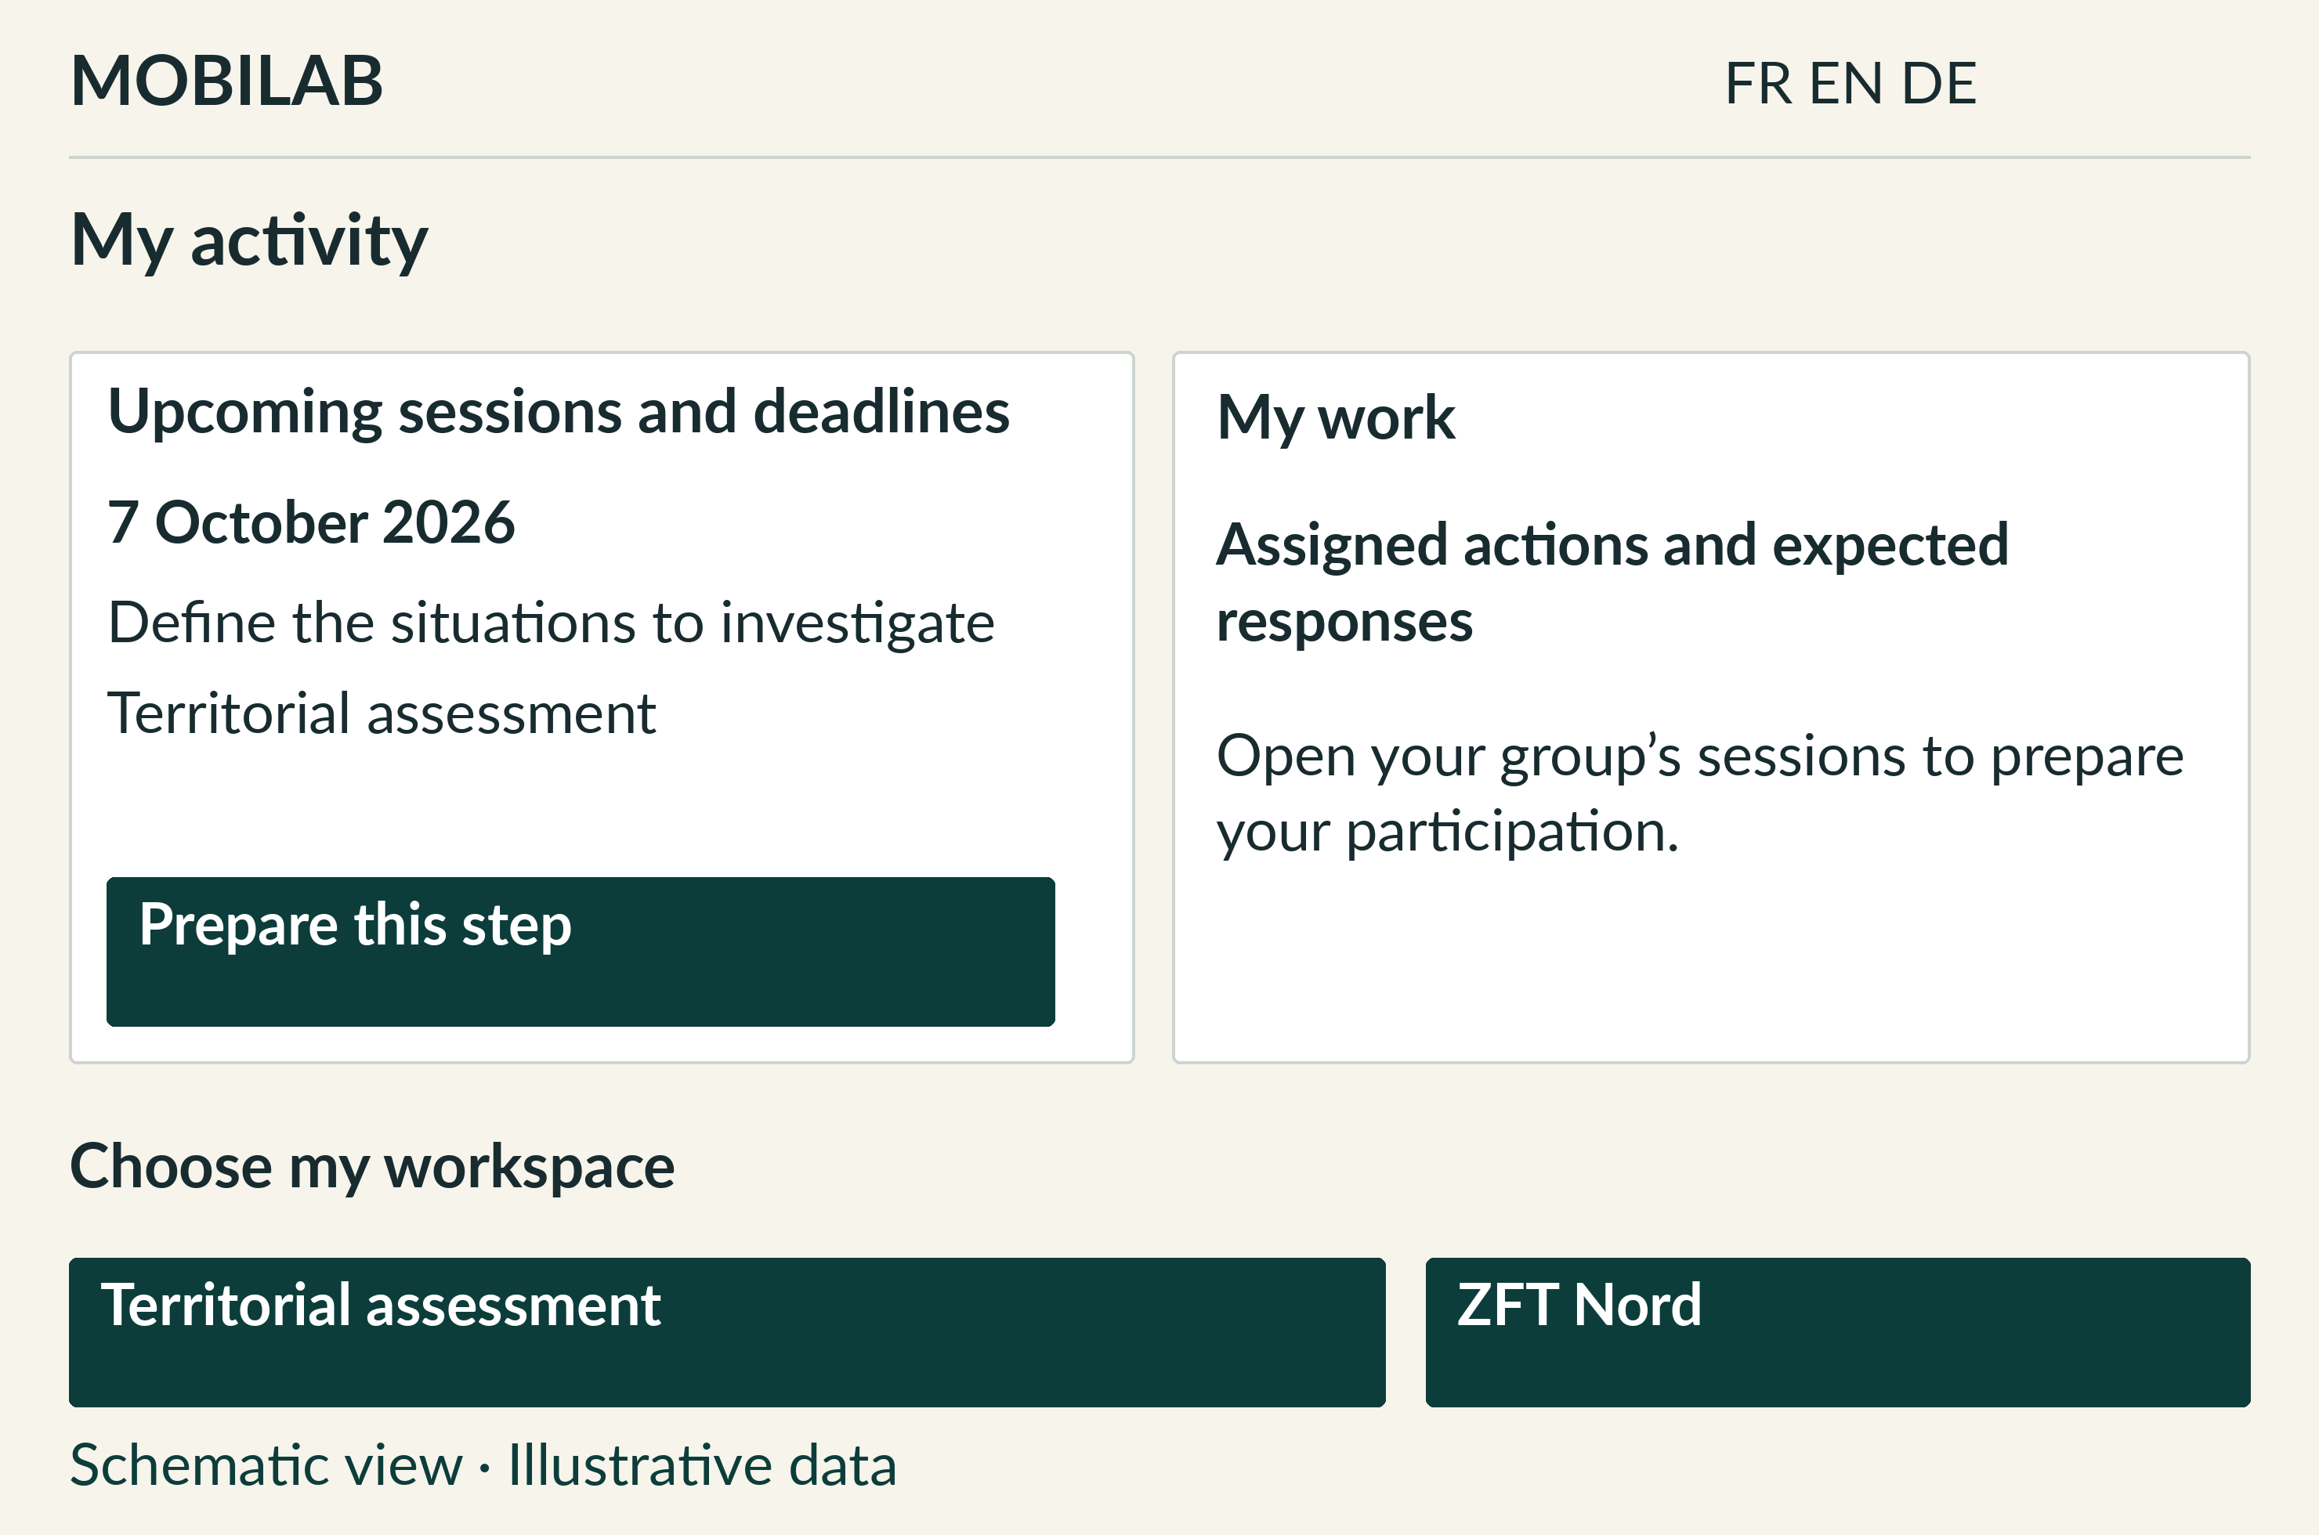
Schematic interface view with illustrative data. The information shown depends on the account and its mandate.
Next deadline. Open the listed session or action and read its status. “Proposed date” means the schedule remains to be confirmed.
My actions and questions. Find actions assigned to you and questions addressed to your groups. Links open the relevant scope.
Recent activity. View authorised changes and open the corresponding contribution or case. On a first visit, this log is not a record of changes since an earlier visit.
Assistant. “Ask a question” opens help at the bottom of the page. You can view your work without activating it.

4. Choose a project and group
In “My pathways”, use “Change pathway”, then “Open”. The selection organises the screen; it does not change your permissions.
Pathway | Use
Territorial assessment | Prepare shared cases and the four groups' work.
ZFT Sud · ZFT Nord · TNT Chiers-Alzette | Follow work in the European project you contribute to.
LTC · PSP / PSP outputs | Find the educational strand and authorised educational outputs.
Existing MOBILAB-ZFT tracking | Access work within the original scope if your mandate allows.

The four working groups
Group | Central question
GT1 · Uses and user groups | For whom, for which tasks and under what usage conditions?
GT2 · Vehicles, safety and maintenance | With which vehicles, safety conditions and maintenance resources?
GT3 · Governance, funding and law | With what responsibilities and organisational conditions?
GT4 · Data, evaluation and transfer | With what records, comparisons and transferability limitations?

The group selector provides access to groups assigned to your account. The five tabs are “My workspace” (or “My group”), “Sessions and deadlines”, “Cases and contributions”, “Outputs” and “Resources”.
Read the status. A project or date appearing on the platform is neither a partner commitment, awarded funding nor permission to experiment.

5. Prepare and follow a session
From your group, open “Sessions and deadlines”. The sheet brings together preparation, the agenda and expected work.
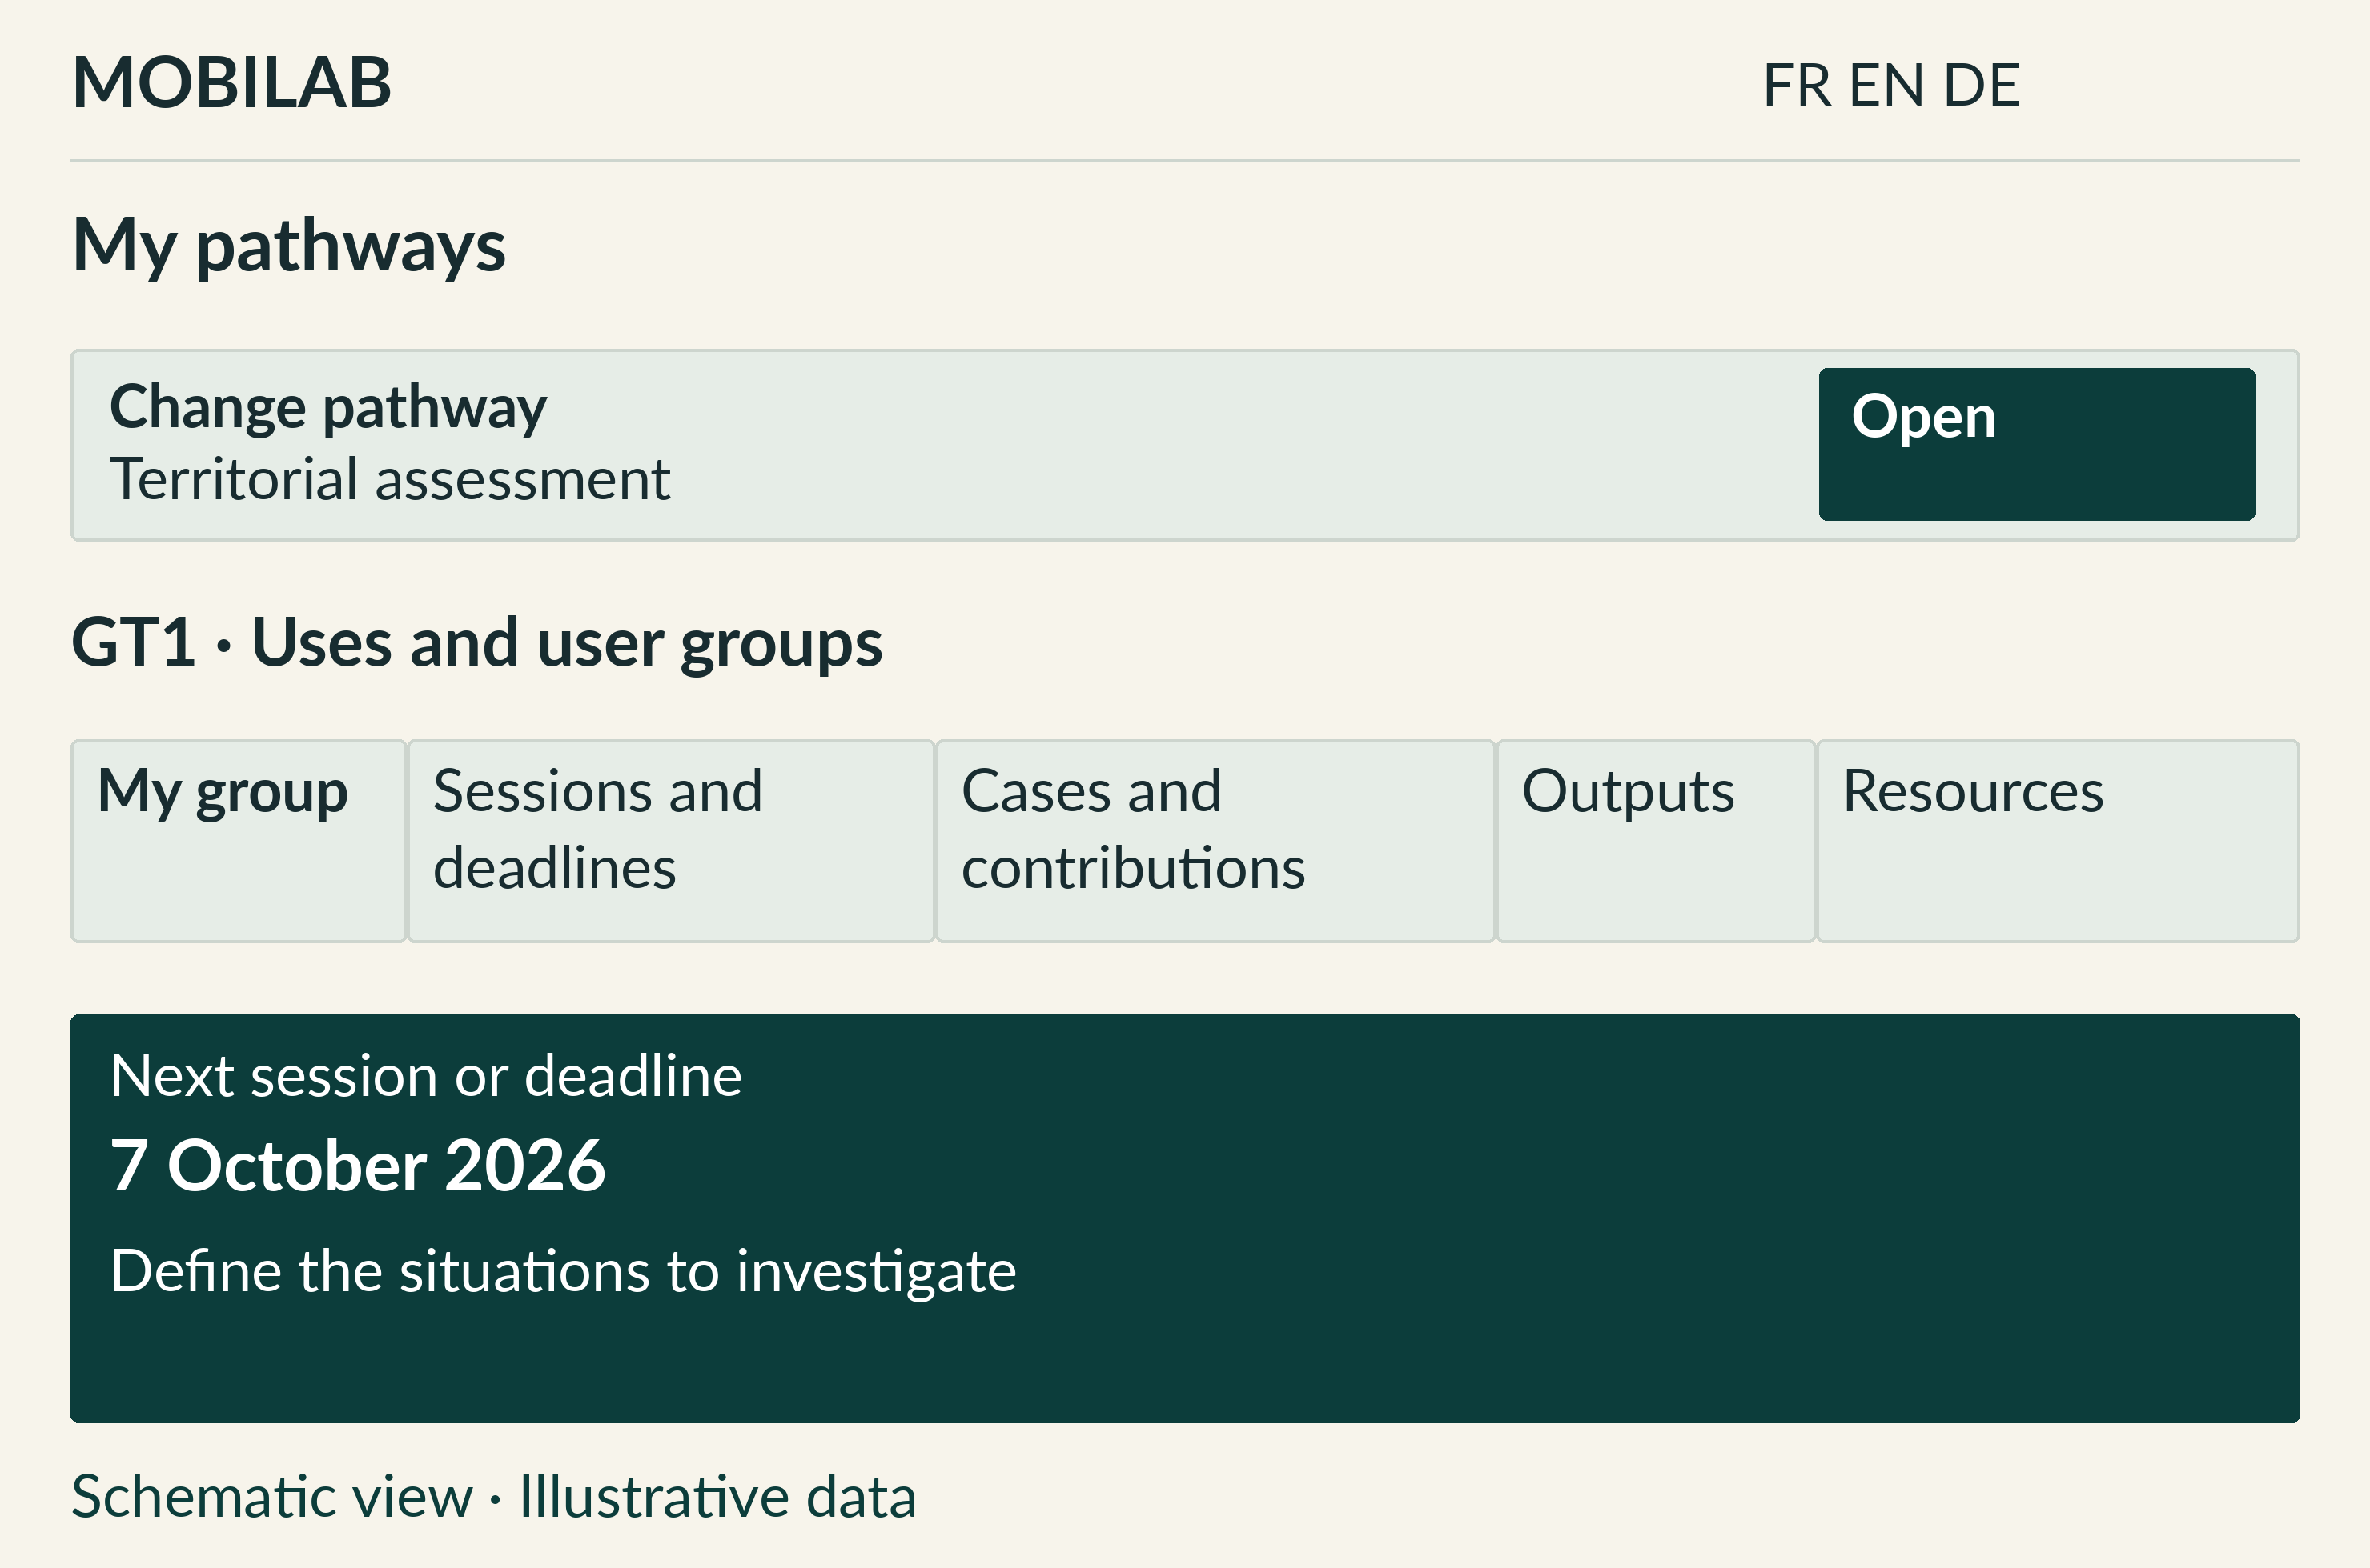
Schematic interface view with illustrative data. The information shown depends on the account and its mandate.
Before. Check the date and status, read “Before the session”, then open the workbook and useful sources. Collect observations and questions relating to the case.
During. Use the group protocol: question to investigate, method, comparison, records sought and disagreements. Decisions remain assigned to competent people.
After. Submit the expected contributions and references. In “Outputs”, check the result to produce and elements still missing.
“Prepare this session with the assistant” retains the session context. Coordination may confirm or revise tracking information. Check the saved status before arranging travel.

6. Submit a contribution
A contribution documents a situated observation or question. It may be linked to a shared case without becoming that case's conclusion.
- Open your project and group, then “Cases and contributions”. Select the case if it exists and choose “Submit a contribution”.
- Complete “Task or observed situation”, then “Observation and question to assess”. Describe what you observed, uncertainties and available sources.
- Check organisation, territory, period, project, group and case. The selected context is carried into the form; some fields are locked to prevent an accidental scope change.
- Open “Enter field measurements” if you have figures, then “Complete the protocol and evidence” to describe sources, method and limitations.
- Choose the status, attach useful documents, then click “Save contribution”. The saved sheet opens at its own address.

The useful minimum
A precise task, dated facts and an explicit question make a contribution usable. Distinguish observation, interpretation and what still needs checking. Write “not measured” in the note if you have no measurement: counters prefilled with zero do not prove absence of a phenomenon.

Find and share the sheet
Open its link from “My activity” or “Cases and contributions”. You may share the address with an authorised colleague; the link gives them no new permissions.
Saving error. Read the displayed message, correct the relevant field and try again. Text appearing in a form does not mean it has been saved.

7. Support, attach and correct
The protocol connects the situation, observation conditions, comparator, evidence and limits of interpretation.

Describe the evidence
Enter the user group, vehicle or mode, route, comparator and observed conditions. Add the source and date, a useful link, evidence level, contradictions and provisional verdict. Retain limitations on generalisation.

Attach documents
“+ Attach documents” accepts up to five files: maximum 10 MB each and 25 MB in total. Formats: PDF, DOCX, ODT, PPTX, XLSX, CSV, TSV, TXT, MD, JSON, PNG, JPG, JPEG or WEBP. Convert older DOC, XLS or PPT formats before sending.
Choose the suggested document status and sensitivity. Attachments remain subject to the contribution's scope. “Shareable” does not make a file public. An attachment is not automatically a reference document indexed by the assistant.
Status | What it indicates
In progress | A contribution still in progress.
To be analysed | A dossier requiring review.
Validated | Documentary validation by an authorised role.
Suspended | Use interrupted pending clarification.

Correct a sheet
Open the contribution. Correction controls depend on your role and authorship. Add useful information and explain the correction when a reason is requested. Corrections remain attributed and timestamped; validation statuses are reserved for authorised roles.
Scope of validation. “Validated” does not replace road-use permission, institutional agreement or a scientific decision. These must be documented separately.

8. Read and find documents
The “Resources” tab in your pathway gathers authorised references. Search helps find a title, group or subject.
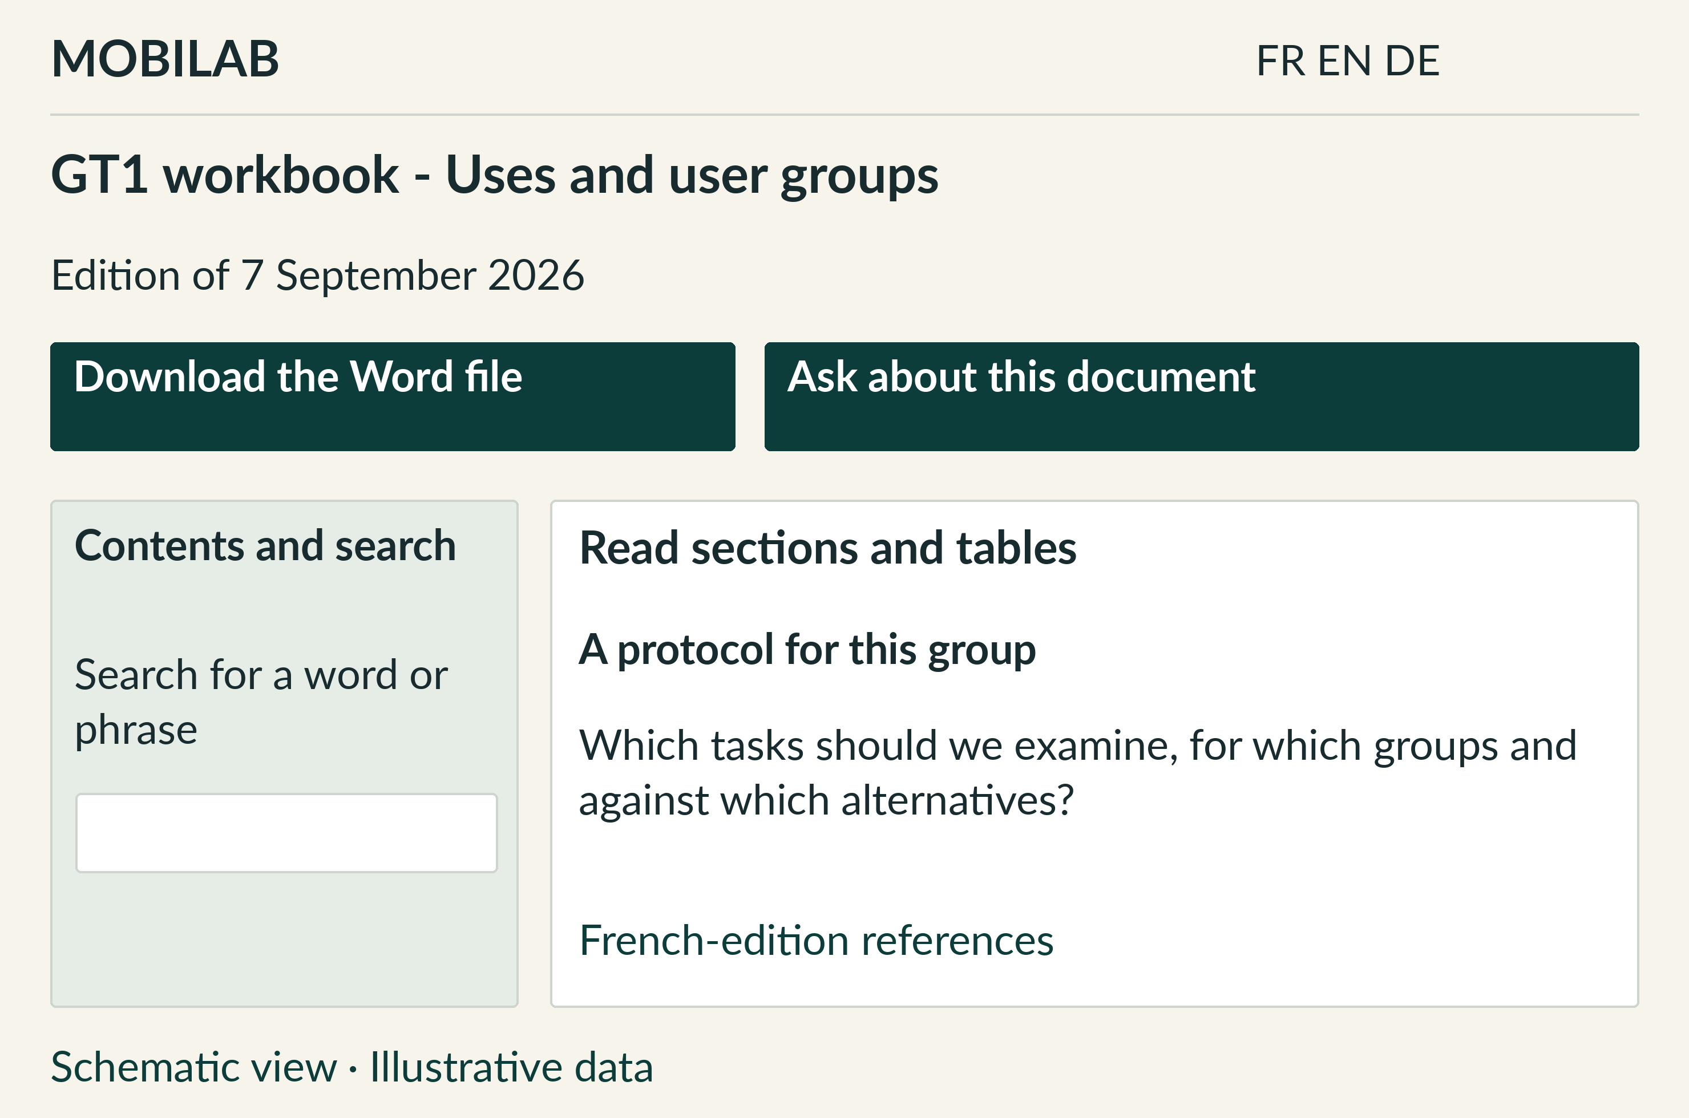
Schematic interface view with illustrative data. The information shown depends on the account and its mandate.
- Open “Read online” to view content on screen. The contents list takes you to a section; search filters relevant sections.
- Download the Word file to work on a copy. Check title, date and status before using it. Changing your copy does not replace the reference document.
- Choose “Ask about this document” to prepare a question in the assistant. Check the context, then start the search with “Ask”.
Reference pages remain available for checking citations. Public documents are also in “Resources” on the website, with PDF viewing and download; the manual is available as PDF and Word.
Choose FR, EN or DE in the language selector. Pages, reference documents and their downloads follow the selected language. French remains the editorial source. Personal contributions retain their original language. For internal documents, citation references point to the French edition; pagination may differ in translations.
Title convention: YYYYMMDD Title - Subtitle. Example: 20260905 Shared sheets - Mobilab Greater Region.

9. Ask the assistant
The assistant helps find sources and prepare work. It remains read-only: it submits no contributions and validates no decisions.
- Open “Ask a question”. From a project, group, case or session, the selected context narrows the search.
- Write a concrete question or select a suggestion. Example: “What records should I prepare for my group's next session?”
- Click “Ask”. Read the answer and sources; open the useful reference or contribution to check the cited passage.
Mode | How it works
Documentary | Searches authorised references and contributions. Available without a local model.
Optional local synthesis | WebLLM produces a synthesis on your device from the documentary context provided by the platform.

Enable or stop local synthesis
Open “Optional local synthesis”, then “Download WebLLM · approximately 1.1 GB”. Wait until ready. Your browser must support WebGPU. Once enabled, the model can be loaded from cache the next time you open the assistant.
“Use documentary mode” disables automatic reloading. Model files may remain in your browser cache. If loading or synthesis fails, documentary search remains available.

Add local text
When WebLLM is ready, “+ Add local text” accepts up to three files of 2 MB each: TXT, MD, CSV, TSV or JSON. They stay on your device and are not contributions. Reload the page to remove these texts from subsequent questions; individual removal is not available in this edition.
Check before reusing. A synthesis can be wrong. Return to sources, retain their dates and statuses, and leave decisions to the people responsible.

10. Work across groups
The shared case is the meeting point. Each group retains its contributions, sources and role in the inquiry.

Send a question linked to a case
- In “Cases and contributions”, open the relevant case and “Questions between groups”.
- Choose “Send a question to another group”. Check the case, your group, the recipient group and proposed deadline.
- Formulate a precise question, add a useful reference, then choose “Save question”.
- The authorised recipient group can use “Answer and references”, then “Submit answer”. The answer retains its author and date.
Question and answer are visible within the case's authorised scope for the groups concerned. They do not open another contribution's attachments to someone without access. A proposed deadline is not an automatic commitment by the recipient.

Use discussions
“Discussions” opens channels you can access. Use them to organise work and exchange. Record lasting observations and evidence in a contribution, then link to its sheet. Historical channels retain their own rights; their name creates no mandate in a new group.

Set alerts
In “My account”, then “Email alerts”, set and save available preferences. Sending depends on email-service activation. Check on-screen information; tracking within the platform remains available even if no sending is configured.
Concurrent revision. If a case, action or question has changed meanwhile, reload the sheet and compare information before submitting your revision. An old version must not overwrite newer work.

11. Coordinate and administer
Steering and access controls appear according to account permissions. They complement participants' workflows.

Coordination: make next steps explicit
- In the pathway, open a shared case, assign its territory and document the situation, status and revisions.
- In session and action tracking, specify a responsible person, date, expected work and status. Explain changes and conditions for moving to the next stage.
- In “My account”, then “Steering”, view available actions, expected evidence and decision points. Tracking indicators are not validated scientific results.

Administration: assign precise mandates
Under “My account”, “Access administration” lets authorised roles manage organisations, invitations and access. Check the address, role, projects, territories, groups and assigned cases. Choose the invitation message language: French, English or German. The platform attempts to send the invitation message and displays the result. If sending fails, the responsible person can forward the personal link provided.
Access expiry or revocation does not delete contribution history. A person can receive several pathways with an existing account. Historical rights are not automatically converted into rights on new projects.

Update the document corpus
Administrative import accepts a document up to 50 MB. Enter its title, status and scope, then check extraction and indexing results. Storing a file, especially an image or scan, does not guarantee usable text is available to the assistant.
New references must retain the title convention, an identifiable version and valid links. When replacing one, check that it opens and that the assistant finds passages. Preloaded programme references are also part of platform updates.
Controlled publication. Explicitly choose documents intended for the public site. Internal team or board documents remain in their authorised space.

12. Resolve a blockage
Before repeating an operation, read the displayed message and check the account, pathway and sheet status.
Situation | What to do
Expired invitation | Ask coordination for a new link.
Missing project or group | Check “Profile and permissions” and request mandate correction.
Inaccessible document | Check account and scope. Request access or report the affected link.
File rejected | Check format, the 10 MB per file limit, five files and 25 MB total.
Change rejected | Reload the sheet: its state or version may have changed.
WebLLM unavailable | Use documentary mode; retry the model on a compatible device.
Unhelpful answer | Specify the case, session or document and check displayed sources.
Storage unavailable | Wait for recovery and check the sheet before saving again.

Three distinctions to remember
The pathway identifies the project. The group specifies the inquiry angle. The case gathers the shared situation; contributions document observations and evidence.

Useful links
Open Mobilab and my workspace
Guide and public resources
Assistant notice
Contact coordination: tarik@aerdscheff.lu
To report a problem, state the page, action performed and message received. A screenshot without personal data can help. Never send your password or invitation link.

